King George Chapter of the American Wine Society 
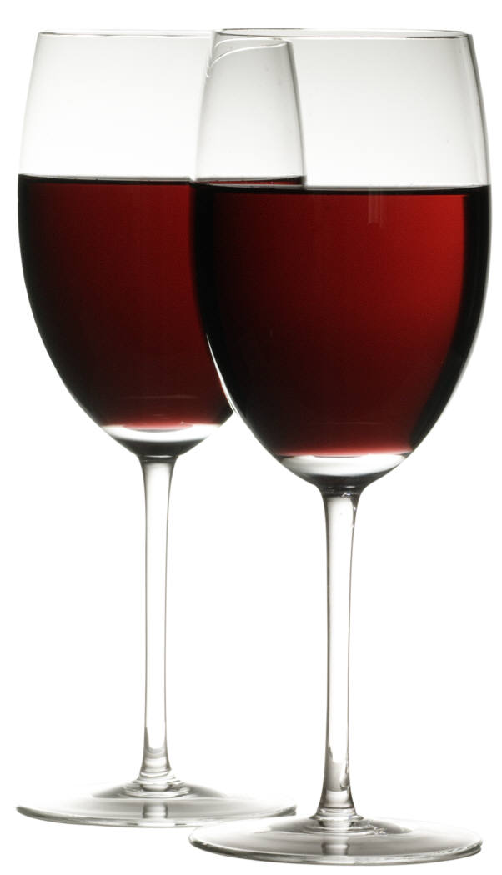
June 17, 2011

General Discussion:
Old News: None
New news:
Items for society discussion/voting:
- Tasting Fee – Raising the fee would allow members presenting to purchase better wines if they choose.
  - The current fee allows for 1oz pours and we have realistically been pouring more of a 2oz pour; which ensures a better ‘taste’ resulting in either loss of wine, or lack thereof.
- Raising the fee to $12.50 – motion was voted and carried.
- ‘Library’ or ‘Special’ tasting meetings where the dues would either be raised or based on attendance should go up for Society/Board approval at least 30 days in advance – Motion voted and carried.
- It is currently in the By-Laws that the Society shall charge ‘Guests’ a fee of $15; the treasurer will now be collecting that fee from this meeting forward.
- We now have an established web site for our Chapter. The nomenclature is KGWinesociety.com

Presentation:
“Recession Wine Values” – Brad Hanna
Wine is stock-piling at many wine distributors due to lack of sales at typically higher prices and is forcing reciprocal shipping. A wine investor can find some exceptional deals right now.
The wines used in Brad’s presentation were graciously chosen out of his own cellar. He brought a collection of wonderful Red’s that have reached their peak and due to a stock-pile of his own cellar, that is representative of the great advantages of being able to purchase wines during this surge of typically higher priced wines being sold at Recession prices. The average consumer is not purchasing high end wines due to the current state of the economy, therefore the wine investor is reaping the benefits of lower prices and can therefore purchase more. Most of these wines were purchased by the case; therefore a case discount was allotted. Some of his wines were purchased at a ‘Futures’ price. ‘Future’s’ are wines that have not been released yet. A consumer is buying on the premise that they know the winemaker is consistent in his product and the investor receives the value of enjoying a considerable discount. Buying ‘Future’s’ is a gamble, however if you do your homework in regards to the winemaker, the viticulture of the wine being made, and/or you have been pleased with what you have enjoyed from that particular winemaker/vineyard you can enjoy a real investment at great prices.
This was an excellent presentation of the benefits of being a savvy wine investor, and how age affects certain wines. Brad also shared a lot of great information and personal experiences with investing, purchasing by case and in the Future’s market.
The wines he shared were:
- #1 - ’07 Londer Vineyards Anderson Valley
Pinot Noir from Mendocino County (North of Sonoma)
The winery owner is a retired Ophthalmologist who decided to get in to wine making.
The vineyard had smoke damage in ’08; had to sell their fruit in bulk
This particular wine was not decanted for our taste.
- #2 - ’07 Palmina, Alisos, Santa Barbara County
Sangiovese/Merlot From the Lompoc area of Santa Barbara Cty
This area enjoys a cool atmosphere. Some think of this area as the ‘Wine Ghetto’, however they put out lovely vintages.
This blend has 20% Merlot; done Chianti style. The winemaker removed a portion of the Sangiovese and racked it for 60 days and then added it back. This style is found in the Veneto region.
- #3 - ’04 Easton, Shenandoah Valley, Amador County
Zinfandel
Very peppery, got a lot of good comments from the group.
- #4 - ’05 Beckman Vineyards Purisima Mtn
Grenache
Grenache is typically a blending wine; this one is a 100% Varietal, a Rhone blend.
- #5 - ’01 Terre Rouge, Noir, Sierra Foothills
Grenache-Mourvedre-Syrah
Each varietal was picked separate, blended separate, but co-fermented.
- #6 -’00 Terre Rouge, Sentinel, Oak Vineyard
Syrah
It is not typical for a Syrah to be this smooth after aging for so long. This Syrah showed very well for its ‘age’! It was even smoother than the previous Syrah blend. There were a lot of pleasantly surprised and positive comments throughout the room.

Favorites and prices of the presentation:
Wine # | Votes | Price at Release | Sold/bought at/Futures Price
#1 | 10 | $32 | $21
#2 | 12 | $28 | $19
#3 | 12 | $28 | $17
#4 | 6 | $34 | $22 (Futures Price)
#5 | 7 | $30 | $21
#6 | 11 | $32 | $20

